**RENTED VEHICLE MANAGEMENT SYSTEM**

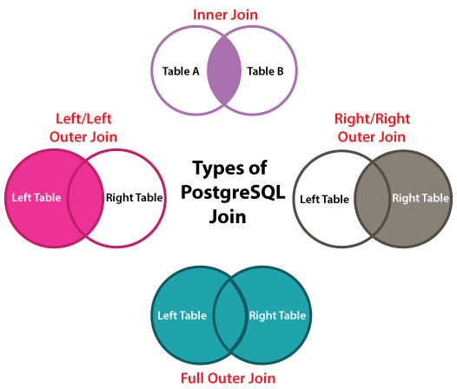

**1) Inner Join**

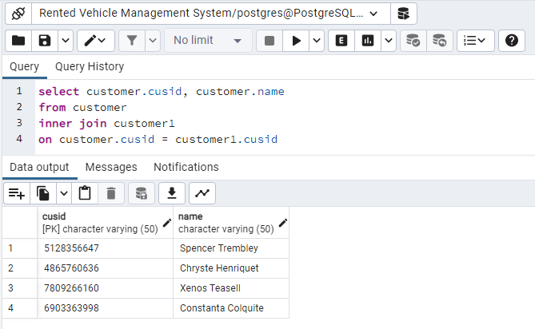

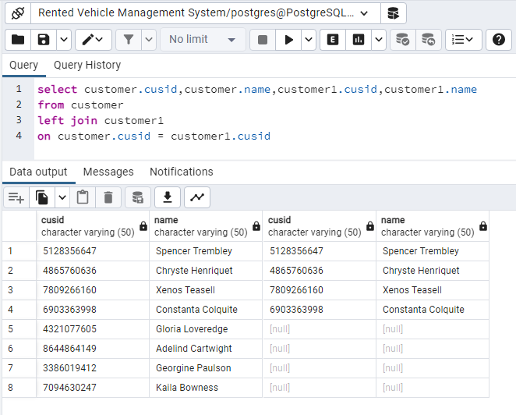**2) Left Join**

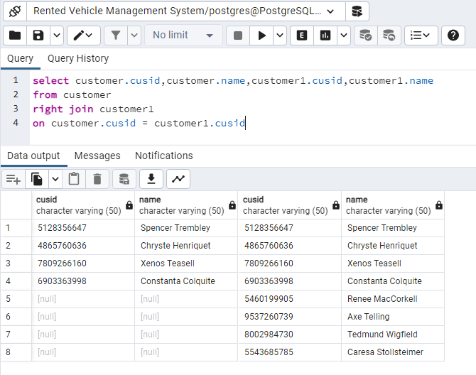**3) Right Join**

If the values are not similar, then the left or right join also produced a new row, which involves the columns from both tables and enhances it to the output.

**4) Full Outer Join**

